Unit I
- What is a forward bias in a PN junction diode
Ans: The positive terminal of the voltage potential is connected to the p- type while
the negative terminal of the voltage potential is connected to the n-type is
called forward bias of a diode
- What is a Reverse bias in a PN junction diode
Ans: The positive terminal of the voltage potential is connected to the n- type while
the negative terminal of the voltage potential is connected to the p-type is
called reverse bias of a diode
- Write the applications of a PN junction diode.
Ans: i). It can be used as a Rectifier
ii) It can be used as a Switch
iii) It can be used as a Clippers and Clampers
iv) It can be used as a Solar Cell
- What is the important application of a Zener Diode.
Ans: 1.Zener diode can be used as a Voltage Regulator
2. Zener diode in over-voltage protection
3. Zener diode can be used as a Clipper
- What is a diode. Explain voltage current characteristics of a PN junction diode with suitable diagrams
Ans: Definition : PN junction is two terminal semiconductor device in which
conducts forward directions and does not conduct reverse directions
Voltage Current characteristics of a PN junction
Zero bias
When the P-N junction diode is in zero bias condition, there is no external
voltage applied and this means that the potential barrier at the junction does
not allow the flow of current.
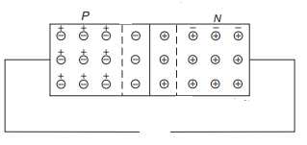
Fig: Zero Bias of a diode
Forward bias
When positive terminal of the battery is connected to the P-type and negative terminal
to the N-type of the PN junction diode, the bias applied is known as forward bias.
As shown in Fig. (a), the applied potential with external battery acts in opposition to the
internal potential barrier and disturbs the equilibrium
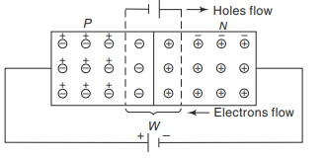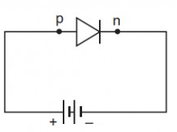
Fig: Forward bias of a Diode
Under the forward bias condition, the applied positive potential repels the holes in P-type region so that the holes move towards the junction and the applied negative potential repels the electrons in the N-type region and the electrons move towards the junction. Eventually, when the applied potential is more than the internal barrier potential, the depletion region and internal potential barrier disappear.
Under forward bias condition, the V–I characteristics of a PN unction diode are shown in Fig.
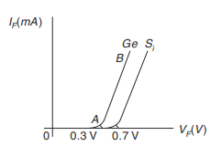
Fig: V-I characteristics of diode under Forward bias
As the forward voltage (V_{F}) is increased, for V_{F} < V_{ʸ}, the forward current IF is almost zero (region OA) because the potential barrier prevents the holes from P-region and electrons from N-region to flow across the depletion region in the opposite direction.
For V_{F} > V_{ʸ}, the potential barrier at the junction completely disappears and hence, the holes cross the junction from P-type to N-type and the electrons cross the junction in the opposite direction, resulting in relatively large current flow in the external circuit.
Reverse bias
When the negative terminal of the battery is connected to the P-type and positive terminal of the battery is connected to the N-type of the PN junction, the bias applied is known as reverse bias
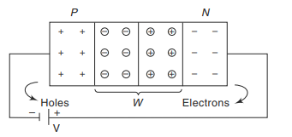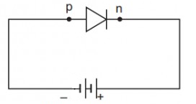
Fig: Reverse bias of a Diode
Under applied reverse bias as shown in Fig. holes which form the majority carriers of the P-side move towards the negative terminal of the battery and electrons which form the majority carrier of the N-side are attracted towards the positive terminal of the battery. Hence, the width of the depletion region which is depleted of mobile charge carriers increases. Thus, the electric field produced by applied reverse bias, is in the same direction as the electric field of the potential barrier.
Therefore, theoretically no current should flow in the external circuit. But in practice, a very small current of the order of a few microamperes flows under reverse bias as shown in Fig
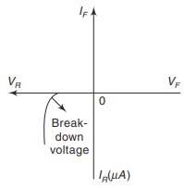
Fig: Reverse bias of a PN junction Diode
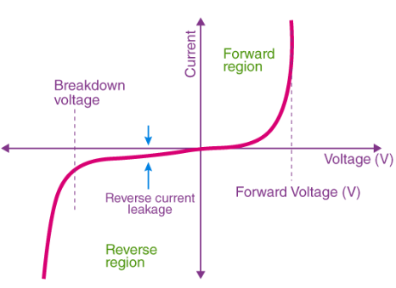
VI characteristics of a PN junction diode
- Breakdown mechanisms in a diode
The sharp increasing current under breakdown conditions is due to the following two mechanisms. (1) Avalanche breakdown (2) Zener breakdown
Avalanche Breakdown
As the applied reverse bias increases, the field across the junction increases correspondingly. Thermally generated carriers while traversing the junction acquire a large amount of kinetic energy from this field. As a result the velocity of these carriers increases. These electrons disrupt covalent bond by colliding with immobile ions and create new electron-hole pairs. These new carriers again acquire sufficient energy from the field and collide with other immobile ions thereby generating further electron–hole pairs. This process is cumulative in nature and results in generation of avalanche of charge carriers within a short time. This mechanism of carrier generation is known as Avalanche multiplication.
When the P and N regions are heavily doped, direct rupture of covalent bonds takes place because of the strong electric fields, at the junction of PN diode. The new electron–hole pairs so created increase the reverse current in a reverse biased PN diode. The increase in current takes place at a constant value of reverse bias typically below 6 V for heavily doped diodes.

Zener breakdown
When the P and N regions are heavily doped, direct rupture of covalent bonds takes place because of the strong electric fields, at the junction of PN diode. The new electron–hole pairs so created increase the reverse current in a reverse biased PN diode. The increase in current takes place at a constant value of reverse bias typically below 6 V for heavily doped diodes.
For lightly doped diodes, Zener breakdown voltage becomes high and breakdown is then predominantly by Avalanche multiplication. Though Zener breakdown occurs for lower breakdown voltage and Avalanche breakdown occurs for higher breakdown voltage, such diodes are normally called Zener diodes.
- Describe the VI characteristics of Zener diode with suitable diagrams
Forward bias
Under the forward bias condition, the applied positive potential repels the holes in P-type region so that the holes move towards the junction and the applied negative potential repels the electrons in the N-type region and the electrons move towards the junction. Eventually, when the applied potential is more than the internal barrier potential, the depletion region and internal potential barrier disappear.
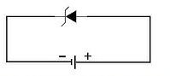
Fig: Forward bias of a zener diode
Under forward bias condition, the V–I characteristics of a Zener diode are shown in Fig
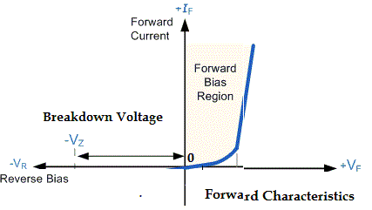
Fig: V-I characteristics of Zener diode under Forward bias
Reverse Characteristics
As we increase the reverse voltage, initially a small reverse saturation current Io. Which is in A, will follow. This current flows due to the thermally generated minority carriers. At a certain value of reverse voltage, the reverse current will increase suddenly and sharply. This is an indication that the breakdown has occurred. This breakdown voltage is called as Zener breakdown voltage or Zener voltage and it is denoted by Vz.
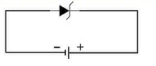
Reverse bias of a zener diode
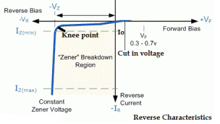
Fig: Reverse characteristics of a Zener diode
Fig: V-I characteristics of a Zener diode under Reverse bias
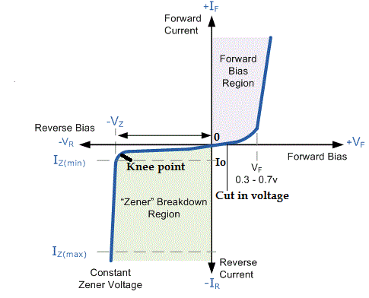
Fig; V-I Characteristics of a Zener diode
- Define Transistor
Ans: A Bipolar Junction Transistor (BJT) is a three terminal semiconductor device in which the operation depends on the interaction of both majority and minority charge carriers and hence the name Bipolar.
- Write any two applications of transistor
Ans: 1.It is used in amplifier and oscillator circuits, and as a switch in digital circuits.
2. It has wide applications in computers, satellites and other modern communication
systems
- Draw the symbols of PNP and NPN transistors.
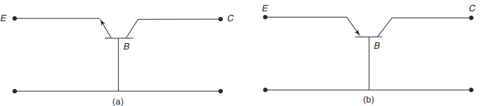
- NPN (b) PNP
- Classify the Three types of transistor configurations
Depending upon the input, output and common terminal, a transistor can be connected in three configurations.
They are: (i) Common base (CB) configuration, (ii) Common emitter (CE) configuration, and (iii) Common collector (CC) configuration
- Write the regions in transistor characteristics.
- Cut off region
- Active region
- Saturation Region
- Draw and explain the input and out characteristics of a BJT in common Base Configuration with the help of circuit diagram
Ans: The circuit diagram for determining the static characteristics curves of an NPN transistor in the common base configuration is shown in Fig.
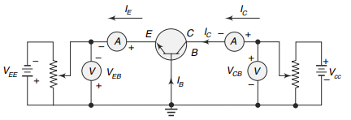
Fig: Circuit to determine the CB characteristics
Input Characteristics:
To determine the input characteristics, the collector-base voltage V_{CB} is kept constant at zero volt and the emitter current I_{E} is increased from zero in suitable equal steps by increasing V_{EB}. This is repeated for higher fixed values of V_{CB}. A curve is drawn between emitter current IE and emitter-base voltage V_{EB} at constant collector-base voltage V_{CB}. The input characteristics thus obtained are shown in Fig.
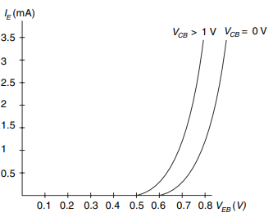
Fig: Input Characteristics
When V_{CB} is equal to zero and the emitter-base junction is forward biased as shown in the characteristics, the junction behaves as a forward biased diode so that emitter current I_{E} increases rapidly with small increase in emitter-base voltage V_{EB}. When V_{CB} is increased keeping V_{EB} constant, the width of the base region will decrease. This effect results in an increase of I_{E}. Therefore, the curves shift towards the left as V_{CB} is increased.
Output Characteristics:
To determine the output characteristics, the emitter current I_{E} is kept constant at a suitable value by adjusting the emitter-base voltage V_{EB}. Then V_{CB} is increased in suitable equal steps and the collector current I_{C} is noted for each value of I_{E}. This is repeated for different fixed values of I_{E}. Now the curves of I_{C} versus V_{CB} are plotted for constant values of I_{E} and the output characteristics thus obtained is shown in Fig
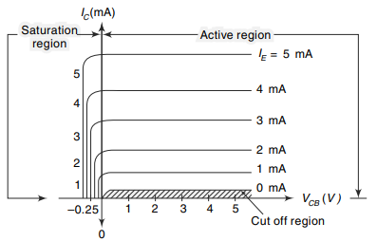
Fig: Output Characteristics
- Draw and explain input and output characteristics of a BJT in a common emitter configuration with the help of circuit diagram
To determine the input characteristics, the collector to emitter voltage is kept constant at zero volts and base current is increased from zero in equal steps by increasing V_{BE} in the circuit shown in Fig.
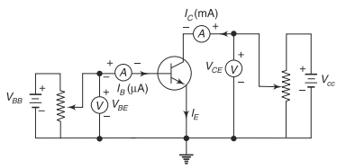
Fig: Circuit to determine the CE characteristics
Input Characteristics:
The value of V_{BE} is noted for each setting of I_{B}. This procedure is repeated for higher fixed values of V_{CE}, and the curves of I_{B} Vs. V_{BE} are drawn. The input characteristics thus obtained are shown in Fig. When V_{CE} = 0, the emitter-base junction is forward biased and the junction behaves as a forward biased diode. Hence the input characteristic for V_{CE} = 0 is similar to that of a forward-biased diode. When V_{CE} is increased, the width of the depletion region at the reverse biased collectorbase junction will increase. Hence the effective width of the base will decrease. This effect causes a decrease in the base current I_{B}. Hence, to get the same value of I_{B} as that for V_{CE} = 0, V_{BE} should be increased. Therefore, the curve shifts to the right as V_{CE} increases.
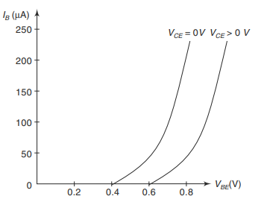

Fig: Input Characteristics
Output Characteristics:
To determine the output characteristics, the base current I_{B} is kept constant at a suitable value by adjusting base-emitter voltage, V_{BE}. The magnitude of collector-emitter voltage V_{CE} is increased in suitable equal steps from zero and the collector current I_{C} is noted for each setting V_{CE}. Now the curves of I_{C} versus V_{CE} are plotted for different constant values of I_{B}. The output characteristics thus obtained are shown in Fig
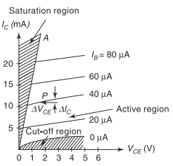
Fig: Output Characteristics
- Draw and explain the input and out characteristics of a BJT in common Collector Configuration with the help of circuit diagram
The circuit diagram for determining the static characteristics of an NPN transistor in the common collector configuration is shown in Fig
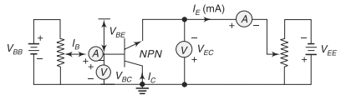
Fig: Circuit to determine the CC characteristics
Input Characteristics:
To determine the input characteristics, V_{EC} is kept at a suitable fixed value. The base-collector voltage V_{BC} is increased in equal steps and the corresponding increase in IB is noted. This is repeated for different fixed values of V_{EC}. Plots of V_{BC} versus I_{B} for different values of V_{EC} shown in Fig. are the input characteristics.
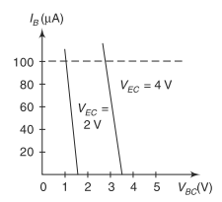
Fig: Input Characteristics
Output Characteristics:
To determine the output characteristics, the base current I_{B} is kept constant at a suitable value by adjusting base-emitter voltage, V_{Bc}. The magnitude of collector-emitter voltage V_{EC} is increased in suitable equal steps from zero and the collector current I_{E} is noted for each setting V_{EC}. Now the curves of I_{E} versus V_{EC} are plotted for different constant values of I_{B}. The output characteristics thus obtained are shown in Fig
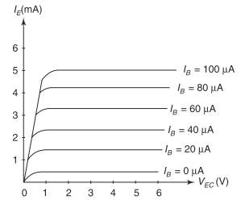
Fig: Output Characteristics
- Define amplifier? Classify and compare the three types of transistor configurations
Amplifier: An amplifier is an electronic device that increases the voltage, current, or power of a signal.
(Or) An amplifier is an electronic device which strengthen the weak signal
- Classify and compare the three types of transistor configurations
Depending upon the input, output and common terminal, a transistor can be connected in three configurations.
They are: (i) Common base (CB) configuration, (ii) Common emitter (CE) configuration, and (iii) Common collector (CC) configuration
Comparison of three types of transistor configurations
